Curriculum Vitae
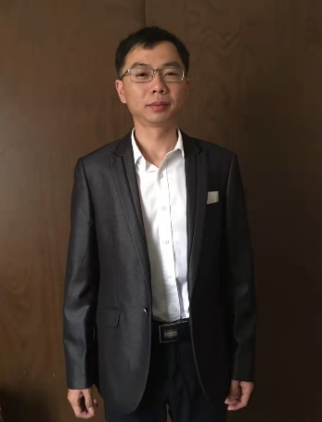
Jun Liu, Ph.D.
Birthday: April 1987
Mailing address:
College of Resources and Environment
Huazhong Agricultural University,
No. 1, Shizhishan Street, Hongshan District, Wuhan,
Hubei 430070, China
Tel: (+86) 13760749483
E-mail: liujun2021@mail.hzau.edu.cn
Citations: 1111, h-index: 13, i10-index: 15

Research Interests
My research interests are to shed light on microbial roles in biogeochemical cycling using omics approaches, and apply microbial biotechnology to remediate heavy metal pollution.

Education
Sep. 2009 - Dec. 2014 Ph.D. in Environmental Science, Sun Yat-sen University, China; Advisor: Prof. Wensheng Shu & Linan Huang
Sep. 2005 - Jun. 2009 B.S. in Bioengineering, Central South University, China; Advisor: Prof. Xueduan Liu

Work Experience
Jan. 2021 - now Huazhong Agricultural University, Senior Research Scientist
Nov. 2017 - Nov. 2020 Postdoctoral Research Associate in geomicrobiology, Miami University; Advisor: Prof. Hailiang Dong
Mar. 2015 - Dec. 2019 Postdoctoral Research Associate in microbial ecology, Sun Yat-sen University; Advisor: Prof. Wensheng Shu & Wenjun Li

Publications
- Su XK#, Liu J*#, Chang LC, Hu WZ, Fang Y*, Li JT, Huang LN, Shu WS, Dong HL. Viral insights into the acidification of sulfidic mine tailings. J Hazard Mater, 494, 138754 (2025).
- Hu WZ#, Fang Y#, Hedlund BP, Jiang HC, Yang YG, Xiao CQ, Xu MY, Dong HL, Liu J*. Insights on adaptive strategies and evolution of cable bacteria in saline lakes. Limnol and Oceanogr, (2025).
- Zhang BG, Liu J*, Sheng YZ*, Shi JX, Dong HL*. Disentangling microbial syntrophic mechanisms for hexavalent chromium reduction in autotrophic biosystems. Environ. Sci. Technol. 55, 6340-6351 (2021).
- Liang JL#, Liu J#, Jia P#, Yang TT, Zeng QW, Zhang SC, Liao B, Shu WS, Li JT. Novel phosphate-solubilizing bacteria enhance soil phosphorus cycling following ecological restoration of land degraded by mining. ISME J. 14, 1600-13 (2020). (1% ESI)
- Liang JL#, Liu J#, Yang TT, Wang PD, Zhang SC, Jia P, Liao B, Shu WS, Li JT. Contrasting soil fungal communities at different habitats in a revegetated copper mine wasteland. Soil Ecology Letters. 2, 8-19 (2020).
- Fang Y#, Liu J#, Kong GN#, Liu XD, Yang YG, Li EZ, Chen XJ, Song D, You XJ, Sun GP, Guo J, Xu MY. Adaptive responses of Shewanella decolorationis to the toxic organic extracellular electron acceptor in anaerobic respiration. Appl. Environ. Microbiol. (2019). (Cover paper)
- Liu J, Chen X, Shu HY, Lin XR, Zhou QX, Bramryd T, Shu WS, Huang LN. Microbial community structure and function in sediments from e-waste contaminated rivers at Guiyu area of China. Environ. Pollut. 235, 171-179 (2018). (1% ESI)
- Yang TT#, Liu J#, Chen WC, Chen X, Shu HY, Jia P, Liao B, Shu WS, Li JT. Changes in microbial community composition following ecological restoration of an extremely acidic Cu mine tailings. Soil Biol. Biochem. 114, 52-58 (2017).
- Liu J#, He XX#, Lin XR, Chen WC, Zhou QX, Shu WS, Huang LN. Ecological effects of combined pollution associated with e-waste recycling on the composition and diversity of soil microbial communities. Environ. Sci. Technol. 49, 6438-6447 (2015).
- Liu J, Hua ZS, Chen LX, Kuang JL, Li SJ, Shu WS, Huang LN. Correlating microbial diversity patterns with geochemistry in an extreme and heterogeneous mine tailings environment. Appl. Environ. Microbiol. 80, 3677-3686 (2014).

