CURRICULUM VITAE

Personal Information |  |  |  |  | 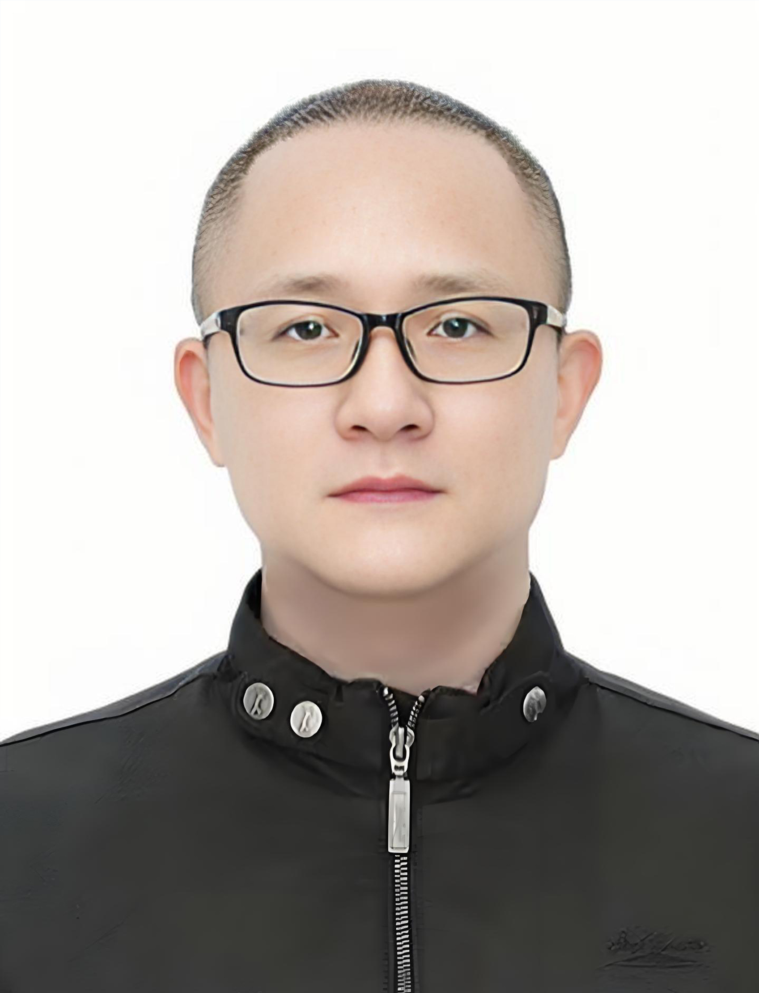
Name | Tan Zuojun | Gender | Male
Position Title |  | Professor
Working Department |  | College of Engineering, Huazhong Agricultural University
Email | tzj@mail.hzau.edu.cn
Address | College of Engineering, Huazhong Agricultural University, Shizishan, Wuhan 430070, China
Tel | +86-27-87282120 |  | Fax
Research Interest
Intelligent Perception and Information Processing; Machine Vision and Image Processing.

Smart Agriculture, particularly novel agricultural sensors and intelligent agricultural equipment.
Preparation and Testing of Energy and Nano Materials from Biomass Conversion, with a focus on novel perovskite materials and devices.
Professional Memberships
Other Roles
Vice Dean, College of Engineering, Huazhong Agricultural University, now

Routine director, Hubei Society for Agricultural Machinery
Director, Hubei Society for Physics
Director, Hubei Society for Optics

Education & Working Experience
Education
Doctor of Engineering, Huazhong University of Science and Technology, 2009

Master of Engineering, Huazhong University of Science and Technology, 2004

Bachelor of Science, Faulty of physics & electronics Hubei University, 1999

Publications
The first author or Corresponding author, Publishing more than 80 academic paper including 60 papers retrieved by SCI, more than 15 papers retrieved by EI;
The first inventor, Authorized more than 15, national patents including 2 invention patents.
Additional Information
Main National Projects:
Wearable minimally invasive Continuous In Situ Monitoring of H₂O₂ signal and Early prediction mechanism involving in the graft Compatibility for melon/ pumpkin grafting, National Natural Science Foundation of China, 32573119
Research on Feature Extraction and Detection Techniques for Stored Grain Pests in the Terahertz Band, National Natural Science Foundation of China, 31000848
Research on Year-Round Cultivation Mechanisms for High-Quality and High-Yield Edible Fungi and Construction of a Spatiotemporal Habitat Database with 3D Modeling, Ministry of Agriculture and Rural Affairs, National Key R&D Program of China
Research on Cotyledon-Free Grafting Technology for Cucurbit Vegetable Rootstocks and Development of Supporting Devices, The Fundamental Research Funds for the Central Universities (No:2662024JC004)
Honors
He has been recognized as an Outstanding Advisor in the Extracurricular Academic and Scientific Works Competition for university students, and as an Outstanding Class Advisor. He has guided students to win first prize in the National Undergraduate Physics Experiment Competition finals, as well as 15 provincial-level awards in competitions such as the provincial "Challenge Cup." He has supervised the completion of two National Innovation Training Program projects for undergraduates (rated Excellent), two provincial-level innovation projects (rated Excellent), 10 School Student Research Fund (SRF) projects for undergraduates, one scientific and technological innovation project for undergraduates, and one Bachelor's Degree Thesis Innovation Award.
In 2023, he received the Special Award in the Hubei Teaching Innovation Competition. In 2020, he was honored as an Advanced Individual in Teaching Ethics by his university. In 2012, he received the First Prize in Teaching Quality at Huazhong Agricultural University. In 2003, 2004, and 2008, he was awarded the Second Prize in Teaching Quality at Huazhong Agricultural University. In 2004, he received one Second Prize in Teaching Achievements at Huazhong Agricultural University. In 2008, he was awarded one Second Prize in Teaching Achievements at Huazhong Agricultural University. In 2012, he received one Third Prize in Teaching Achievements from Hubei Province, one First Prize in Teaching Achievements from Huazhong Agricultural University, and one Second Prize in Teaching Achievements from Huazhong Agricultural University. In 2016, he was awarded one Second Prize in Teaching Achievements at Huazhong Agricultural University. In 2021, he received one First Prize and one Second Prize in Teaching Achievements at Huazhong Agricultural University. In 2022, he was honored with one Third Prize in Teaching Achievements from Hubei Province. In 2018, he received one Third Prize in the National University Teaching Innovation Competition.

