CURRICULUM VITAE

Personal Information |  |  |  |  | 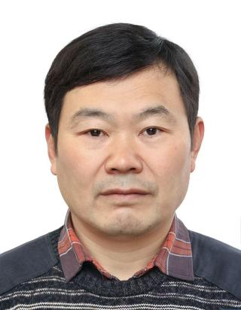
Name | Hou, Dejia | Gender | Male
Position Title |  | Associate Professor
Working Department |  | College of Engineering
Email | Hdj05@hzau.edu.cn
Address | Huazhong Agricultural University
Tel | (0086)027-87282120 |  | Fax | (0086)027-87282120
Research Interest
Mainly engaged in research on mechanized and unmanned operation technologies and equipment for resource utilization of waste materials, specifically involving:
①development and application of bio-conversion of organic wastes;
②development and application of agricultural residues into bio-products technologies and equipment;
③development and application of Water and Environmental Engineering.
Professional Memberships
Member of the research team for Key Laboratory of Agricultural Equipment in the Middle and Lower Reaches of the Yangtze River, Key Laboratory of Aquaculture Facilities Engineering, Ministry of Agriculture and Rural Affairs;
Will be Visiting Scholar at Cardiff University, UK. (2026-2027)
Other Roles
Senior Member of the Chinese Society of Agricultural Engineering; Member of the Hubei Provincial Society of Agricultural Engineering.
Education & Working Experience
Mr. Hou earned his doctorate and master's degree respectively from HZAU (Huazhong Agricultural University) and WU (Wuhan University).
Publications
- Wancheng Pang#, Dejia Hou#,etc. Production of biodiesel from CO and organic wastes by fermentation and black 2 soldier fly .Renewable Energy( 2020) 149:1174-1181.
- Jiangshan Chen# , Dejia Hou# , etc. Effect of moisture content on greenhouse gas and NH3 emissions from pig manure converted by black soldier fly .Science of the Total Environment( 2019).133840.

See more at: https://faculty.hzau.edu.cn/houdejia

