CURRICULUM VITAE

Personal Information |  |  |  |  | 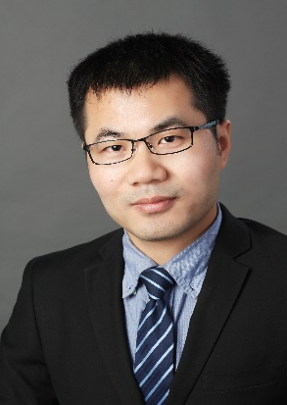
Name | Gucheng Li | Gender | Male
Position Title |  | Professor
Working Department |  | Agricultural Economics and Management
Email | lgcabc@mail.hzau.edu.cn
Address | M432, Building of Social Science and Humanities
Tel | +86-27-87286896 |  | Fax | +86-27-87282973
Research Interest
Agricultural Economics, Agricultural Production Economics
Professional Memberships
Other Roles
Education & Working Experience
Education
Ph. D. 2003-2008. Department of Agricultural Economics and Management, Huazhong Agricultural University.
B. S. 1999-2003. Department of Economics, Huazhong Agricultural University.
Work Experience
November 2015 – present Professor, Department of Agricultural Economics and management, Huazhong Agricultural University.
January 2011 – November 2015 Associate Professor, Department of Agricultural Economics and management, Huazhong Agricultural University.
July 2008 - December 2010 Lecturer, Department of Agricultural Economics and management, Huazhong Agricultural University.
Publications
- Li Gucheng*, Z. Feng and L. You, “Re-examining the Inverse Relationship between Farm Size and Efficiency: the Empirical Evidence in China”, China Agricultural Economic Review (SSCI, SCIE), 2013, 5(4): 473-488.
- Li Gucheng*, L. You and Z. Feng, “The Sources of Total Factor Productivity Growth in Chinese Agriculture: Technological Progress or Efficiency Gain”, Journal of Chinese Economic and Business Studies (UK, EconLit), 2011, 9(2): 181-203.

Additional Information

